#### Program

**WRIST ARTHROSCOPY COURSE**

**Training on Anatomical Specimen**

**Basic and Intermediate Course - Taiwan**

May 29th and 30th, 2021

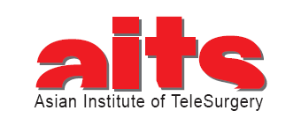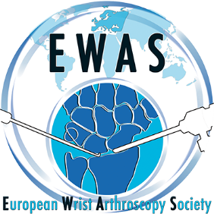

Organized by EWAS

With the support of:

FESSH, Honk-Kong Society for Surgery of the Hand, CUHK Depart. of Orthopaedics and Traumatology

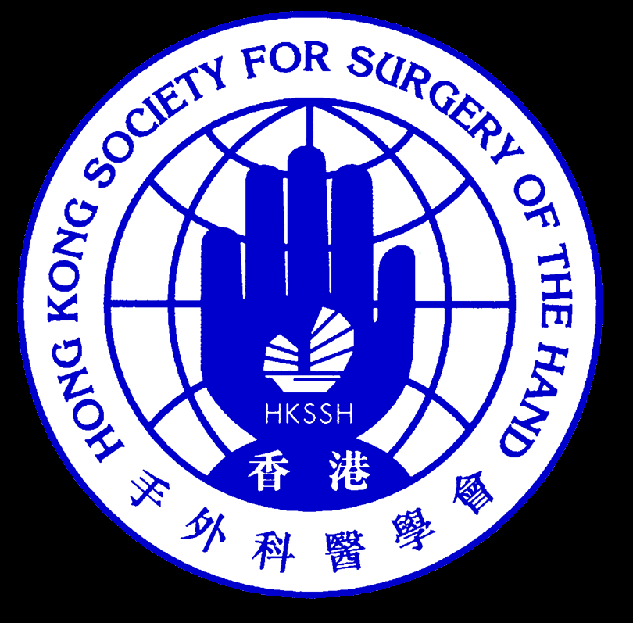 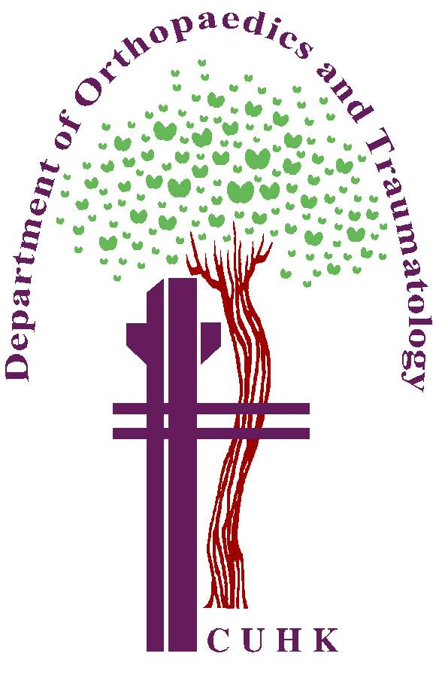

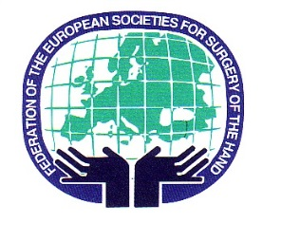

Course Supervisor:

**C. MATHOULIN (France)**

Course Directors:

**T. NAKAMURA (Japan)**

**J.R. HAUGSTVEDT(Norway)**

**W.J. CHEN (Taiwan)**

Faculty:

**Y. ABE (Japan) Y.C, CHIU (Taiwan)**

**H. COERT (Netherland) T. EGI (Japan)**

**K. FUJIO (Japan) P.C. HO (Hong-Kong SAR, China)**

**Y.C. HUANG (Taiwan) Y.K.LEE (Korea)**

**L. MERLINI (France) J.T. SHIH (Taiwan)**

**C. TALEB (France) M. TATEBE (Japan)**

**W.L. TSE (Hong-Kong SAR, China) J.P. Wang (Taiwan)**

**C. WONG (Hong-Kong SAR, China) C.H. Wu (Taiwan)**

*This program may be subject to modifications*

Saturday, 29 May 2021

Morning

|  |  |
| --- | --- |
| 08:15 Lecture 1 | Moderator : T. Nakamura |
| Lecture 1 Basic of wrist arthroscopy   * How to perform wrist arthroscopy : instruments, installation and portal (10 min) * Complications of wrist arthroscopy (10 min) * Arthroscopic ganglionectomy (10 min) * Arthroscopic synovectomy (10 min) * Radial styloidectomy (10 min) | W.J. Chen  Y.C. Huang  Y.C. Chiu  Y.K. Lee  C.H. Wu |
| 9:15 – 12:30 Practical session 1 (part1)  Radiocarpal and midcarpal joints examination  Removal of synovial cyst  Radial styloidectomy |  |
| Experts help students directly at their allocated tables or an anatomical specimen with simultaneous teaching, individual practical training by students  (1 expert for 2 operating tables) | All experts |

Afternoon

|  |  |
| --- | --- |
| 14:00 Lecture 2 | Moderator: PC Ho |
| Lecture 2 SL and DRF   * Scapholunate ligament tears: problems and principles (10 min) * Arthroscopic scaphoid fracture treatment (10 min) * Arthroscopic scaphoid non-union (10 min) * Intraarticular radius fracture: arthroscopic reduction and fixation (10 min) | C. Taleb  H. Coert  W.L. TSE  Y. Abe |
| 15:00 – 17:30 Practical session 2  Basic: Scapholunate tears  Intermediate: scaphoid fracture (arthroscopic or open ), intraarticular distal radius fracture |  |
| Experts help students directly at their allocated tables on an anatomical specimen with simultaneous teaching  Individual practical training by students (1 expert for 2 operating tables) | All experts |
|  |  |

Sunday, 30 May 2021

Morning

|  |  |
| --- | --- |
| 08:30 Lecture 3 | Moderoator : JR Haugstvedt |
| Lecture 3: TFCC problems   * Principles of TFCC repair (10 min) * TFCC peripheral tears : diagnosis and repair (10 min) * TFCC inside-out foveal repair (10 min) * Ulnocarpal abutment syndrome and arthroscopic Wafer procedure (10 min) * Ulnar shortening (10 min) | T. Nakamura  J.R. Haugstvedt  K. Fujio  T. Egi  M. Tatebe |
| 9:30 -12:30 Practical session 3  Basic: TFCC peripheral repair and arthroscopic Wafer procedure  Intermediate: DRUJ arthroscopy, TFCC foveal repair |  |
| Experts help students directly at their allocated tables on an anatomical specimen with simultaneous teaching, individual practical training by students  (1 expert for 2 operating tables)  Students can be separated into basic and intermediate, according to their ability of wrist arthroscopy | All experts |

Afternoon

|  |  |
| --- | --- |
| 14:00 Lecture 4 | Moderator: WJ Chen |
| Lecture 4: Advanced arthroscopic procedures   * Thumb CMC arthroscopy (10 min) * Arthroscopic treatment of STT joint (10 min) * Arthroscopic SL reconstruction (10 min) * Arthroscopic treatment for SLAC 1 and 2 (10 min) | J. T. Shih  C. Wong  P.C. Ho  L. Merlini |
| 15:00 – 17:00 Practical session 4  Basic: Thumb CMC arthroscopy  Intermediate: Arthroscopic SL reconstruction |  |
| Experts help students directly at their allocated tables on an anatomical specimen with simultaneous teaching, Individual practical training by students (1 expert for 2 operating tables)  Students can be separated into basic and intermediate, according to their ability of wrist arthroscopy | All experts |

17:00 End of the course